Gender, Health, and Human Rights Praxis Lab Final Report

**Table of Contents**

Readings 1

Guest Speakers 3

Pitching Spring Project 4

Selecting Spring Project 5

Pursuing Spring Project I: Website 6

Pursuing Spring Project II: Counseling 6

Outcomes 7

Impact 9

Future 10

Acknowledgements 12

**Readings**

Part of our fall semester was dedicated to completing readings in order to approach our spring project with an appropriate knowledge base. These readings included videos and articles from the three foci of the class as well as their intersections.

***Human Rights:***

History of human rights

* “Universal Declaration of Human Rights”
* Video examples: Mozambique, Brazil, and Russia

Types of rights

* “Frequently Asked Questions on Economic, Social, and Cultural Rights" by the Office of the United Nations High Commissioner for Human Rights
* “What Future for Economic and Social Rights?” by David Beetham
* Institutions and treaties
* “List of Human Rights Issues” by the Office of the United Nations High Commissioner for Human Rights
* “Ratification Status by Country or by Treaty” by the Office of the United Nations High Commissioner for Human Rights
* “Human Rights as Myth and Ceremony? Reevaluating the Effectiveness of Human Rights Treaties 1981-2007” by Wade M. Cole

***Gender:***

What is sex and gender?

* “The Genderbread Person”
* “The Medical Construction of Gender: Case Management of Intersexed Infants” by Suzanne J. Kessler
* “Pink and Blue Forever” by Anne Fausto-Sterling
* “Gender and Social Construction: Who? What? When? Where? How?” by Sally Haslanger
* “Night to His Day: The Social Construction of Gender” by Judith Lorber
* “Beyond Difference: A Biologist’s Perspective” by Anne Fausto-Sterling

Gender identity and sexual identity

* “Bathroom battlegrounds and Penis Panics” by Kristen Schilt and Laurel Westbrook
* “Title IX Protections from Bullying and Harassment in Schools: FAQs for LGBT or Gender Nonconforming Students and Their Families”
* “Masculinity as Homophobia: Fear, Shame, and Silence in their Construction of Gender Identity” by Michael S. Kimmel
* “The Invention of Heterosexuality” by Jonathan Ned Katz

***Health:***

What is health?

* “What is Wellness Now?” by Anna Kirkland
* “Theories for Social Epidemiology in the 21st Century: an Ecosocial Perspective” by Nancy Krieger

**Healthcare:**

* “United States Health Care Reform: Progress to Date and Next Steps” by Barack Obama
* “Redefining Global Health-Care Delivery” by Jim Yong Kim, Paul Farmer, and Michael E Porter

***Intersections:***

Gender and health

* “Constructs of Masculinity and their Influence on Men’s Well-Being: A Theory of Gender and Health” by Will H. Courtenay
* “Exploring the Cervical Cancer Screening Experiences of Black Lesbian, Bisexual, and Queer Women: The Role of Patient-Provider Communication” by Madina Agenor, et al.
* “Comprehensive Transgender Healthcare: The Gender Affirming Clinical and Public Health Model of Fenway Health: by Sari L Reisner, et al.

Health and human rights

* “(Public) Health and Human Rights in Practice” by George J Annas and Wendy K Mariner
* “Health and Human Rights: If Not Now, When?” by Jonathan Mann

Gender, health, and human rights

* “Gender, Health, and Human Rights” by Rebecca J. Cook
* “Measuring Women’s Empowerment: Participation and Rights in Civil, Political, Social, Economic, and Cultural Domains” by Valetine M. Moghadam and Lucie Senftova

**Guest Speakers**

Another part of our fall semester was dedicated to guest lectures from a wide variety of physicians, professors, and advocates. Below is a brief overview of our guest speakers.

***Dr. Thomas Maloney:***Director - University of Utah Barbara and Norman Tanner Center for Nonviolent Human Rights. Dr. Maloney spoke about the Tanner Center and what opportunities exist for undergraduate students to get involved.

***Dr. Wade Cole*:** Associate Professor - University of Utah Department of Sociology. Dr. Cole spoke about various treaties and the value of ratifying and signing treaties.

***Dr. Deen Chatterjee:***Senior Advisor and Professorial Fellow - University of Utah S.J. Quinney College of Law. Dr. Chatterjee spoke about human rights, the types of rights, justice, and intersections between health and politics.

***Dr. Nicole Mihalopoulos:***Adolescent Medicine Division Chief - University of Utah Department of Pediatrics. Dr. Mihalopoulos works with transgender youth and she spoke about healthcare for transgender individuals.

***Jessica Lynn:***President - Your True Gender & Transgender Advocate. Jessica is an advocate for transgender individuals; she shared her life story and spoke about discrimination against transgender individuals.

***Dr. Sara Hart:***Associate Professor (Clinical) - University of Utah College of Nursing. Dr. Hart spoke about having a broader perspective on health including population health, public health, and considering social determinants of health.

***Dr. Michael Varner:***Vice-Chair of Research - University of Utah Department of Obstetrics/Gynecology. Dr. Varner spoke about women’s health including, cancer, pregnancy, and reproductive health, as well as about how research intersects with medicine.

***Dr. Holly Bullock:***Family Planning Fellow - University of Utah Department of Obstetrics/Gynecology. Dr. Bullock spoke about birth control and women’s health and how insurance and the healthcare system can determine what sort of care an individual receives.

***Dr. Sharon Talboys:***Assistant Professor - Westminster College Department of Public Health. Dr. Talboys told us about her research in India and how gender, and human rights are perceived their and what can be done to improve conditions for women.

**Pitching Spring Project**

After thoroughly investigating the principles and issues surrounding gender, health, and human rights, the class spent time reflecting upon and discussing each topic and finding areas of overlap. Each student pitched a project proposal to the class to address a community issue that pertained to all three of the class’ focus areas. The proposals had to be feasible within the time span of the spring semester and with the funding provided. Projects also had to have substantial and immediate impact as well as be sustainable so the class efforts could endure after the semester ended.

Each student gave a short, condensed presentation in class clearly stating the issue or research question they were addressing, how it pertained to each foci of the class, and a tentative timeline for project completion. There was a great deal of commonality and agreement in class ideas, so themes quickly emerged. The topics of sexual assault and rape culture came up in a few proposals regarding the campus community specifically. Some proposals addressed concerns of counseling need, bystander intervention training, and overall resources and awareness on campus. The class consensus was to address the spring project in a democratically and fully inclusive manner as the class had always been. The class chose the two most significant, feasible and sustainable elements of the proposals focused on sexual assault. These were the need for counseling and the need for resources and knowledge.

**Selecting Spring Project**

The voting process for the spring project was organized to ensure realistic goals and sustainable impact. Descriptions and details of the three projects that had been selected were presented once again to the class. Students then carefully reviewed and discussed the proposals in small groups in order to identify the strengths and challenges of each potential project.

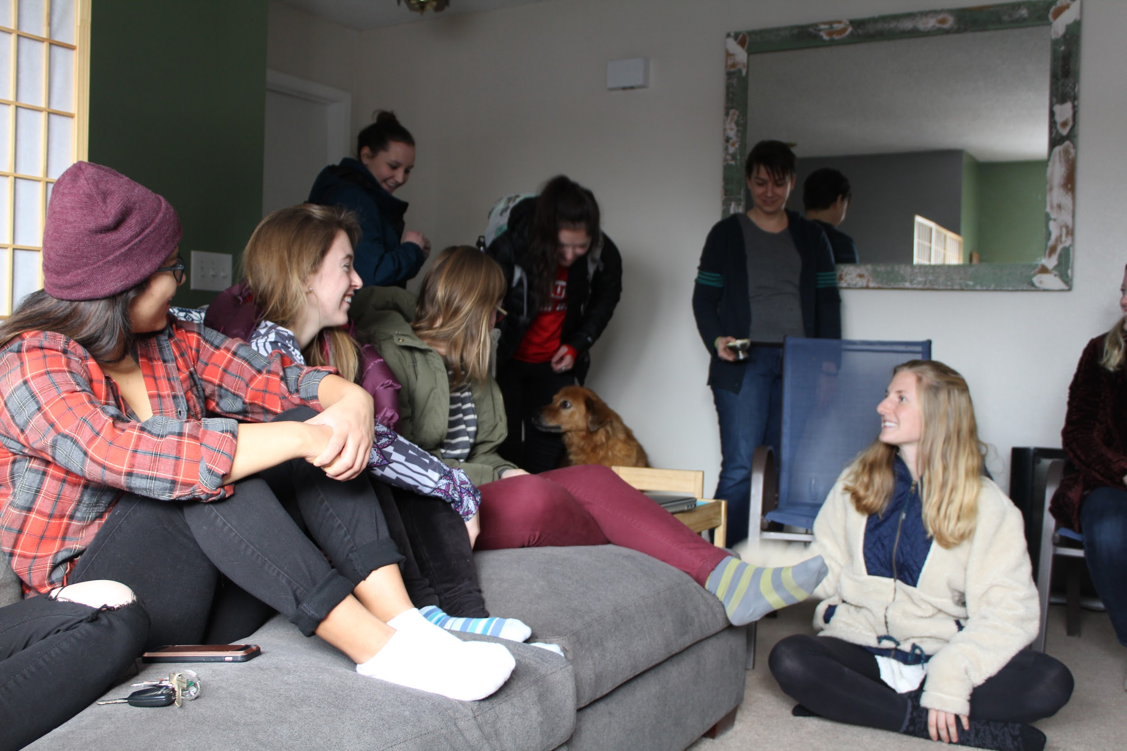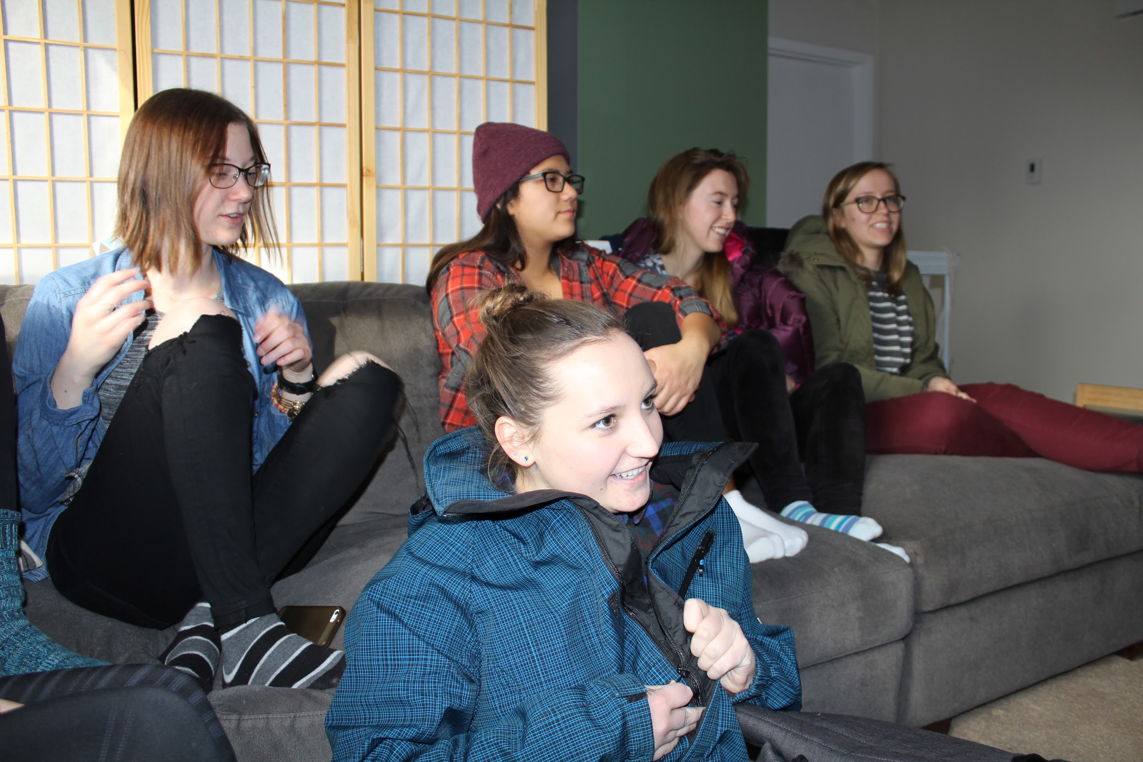

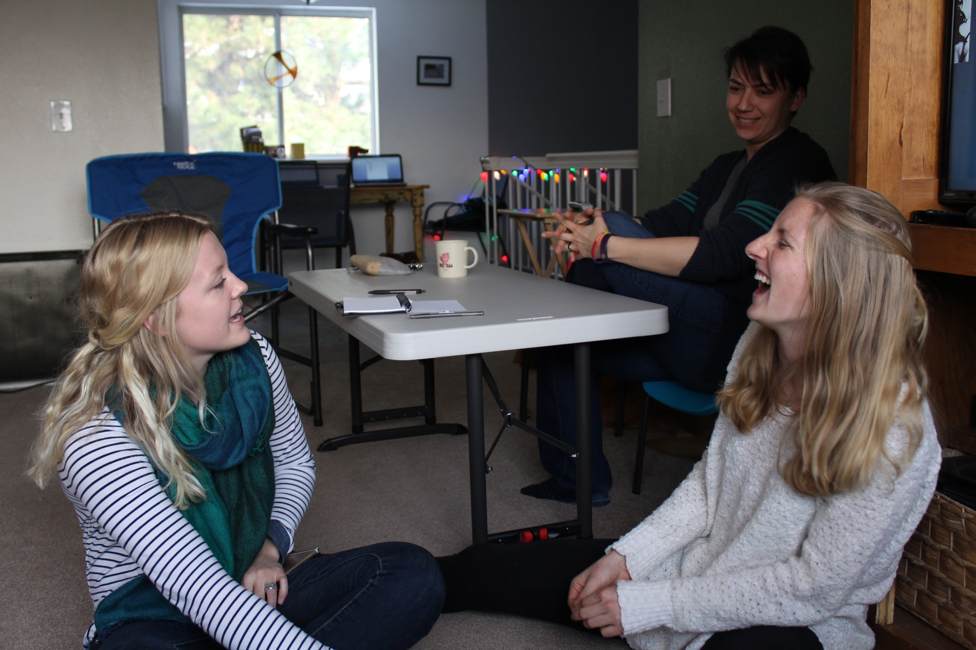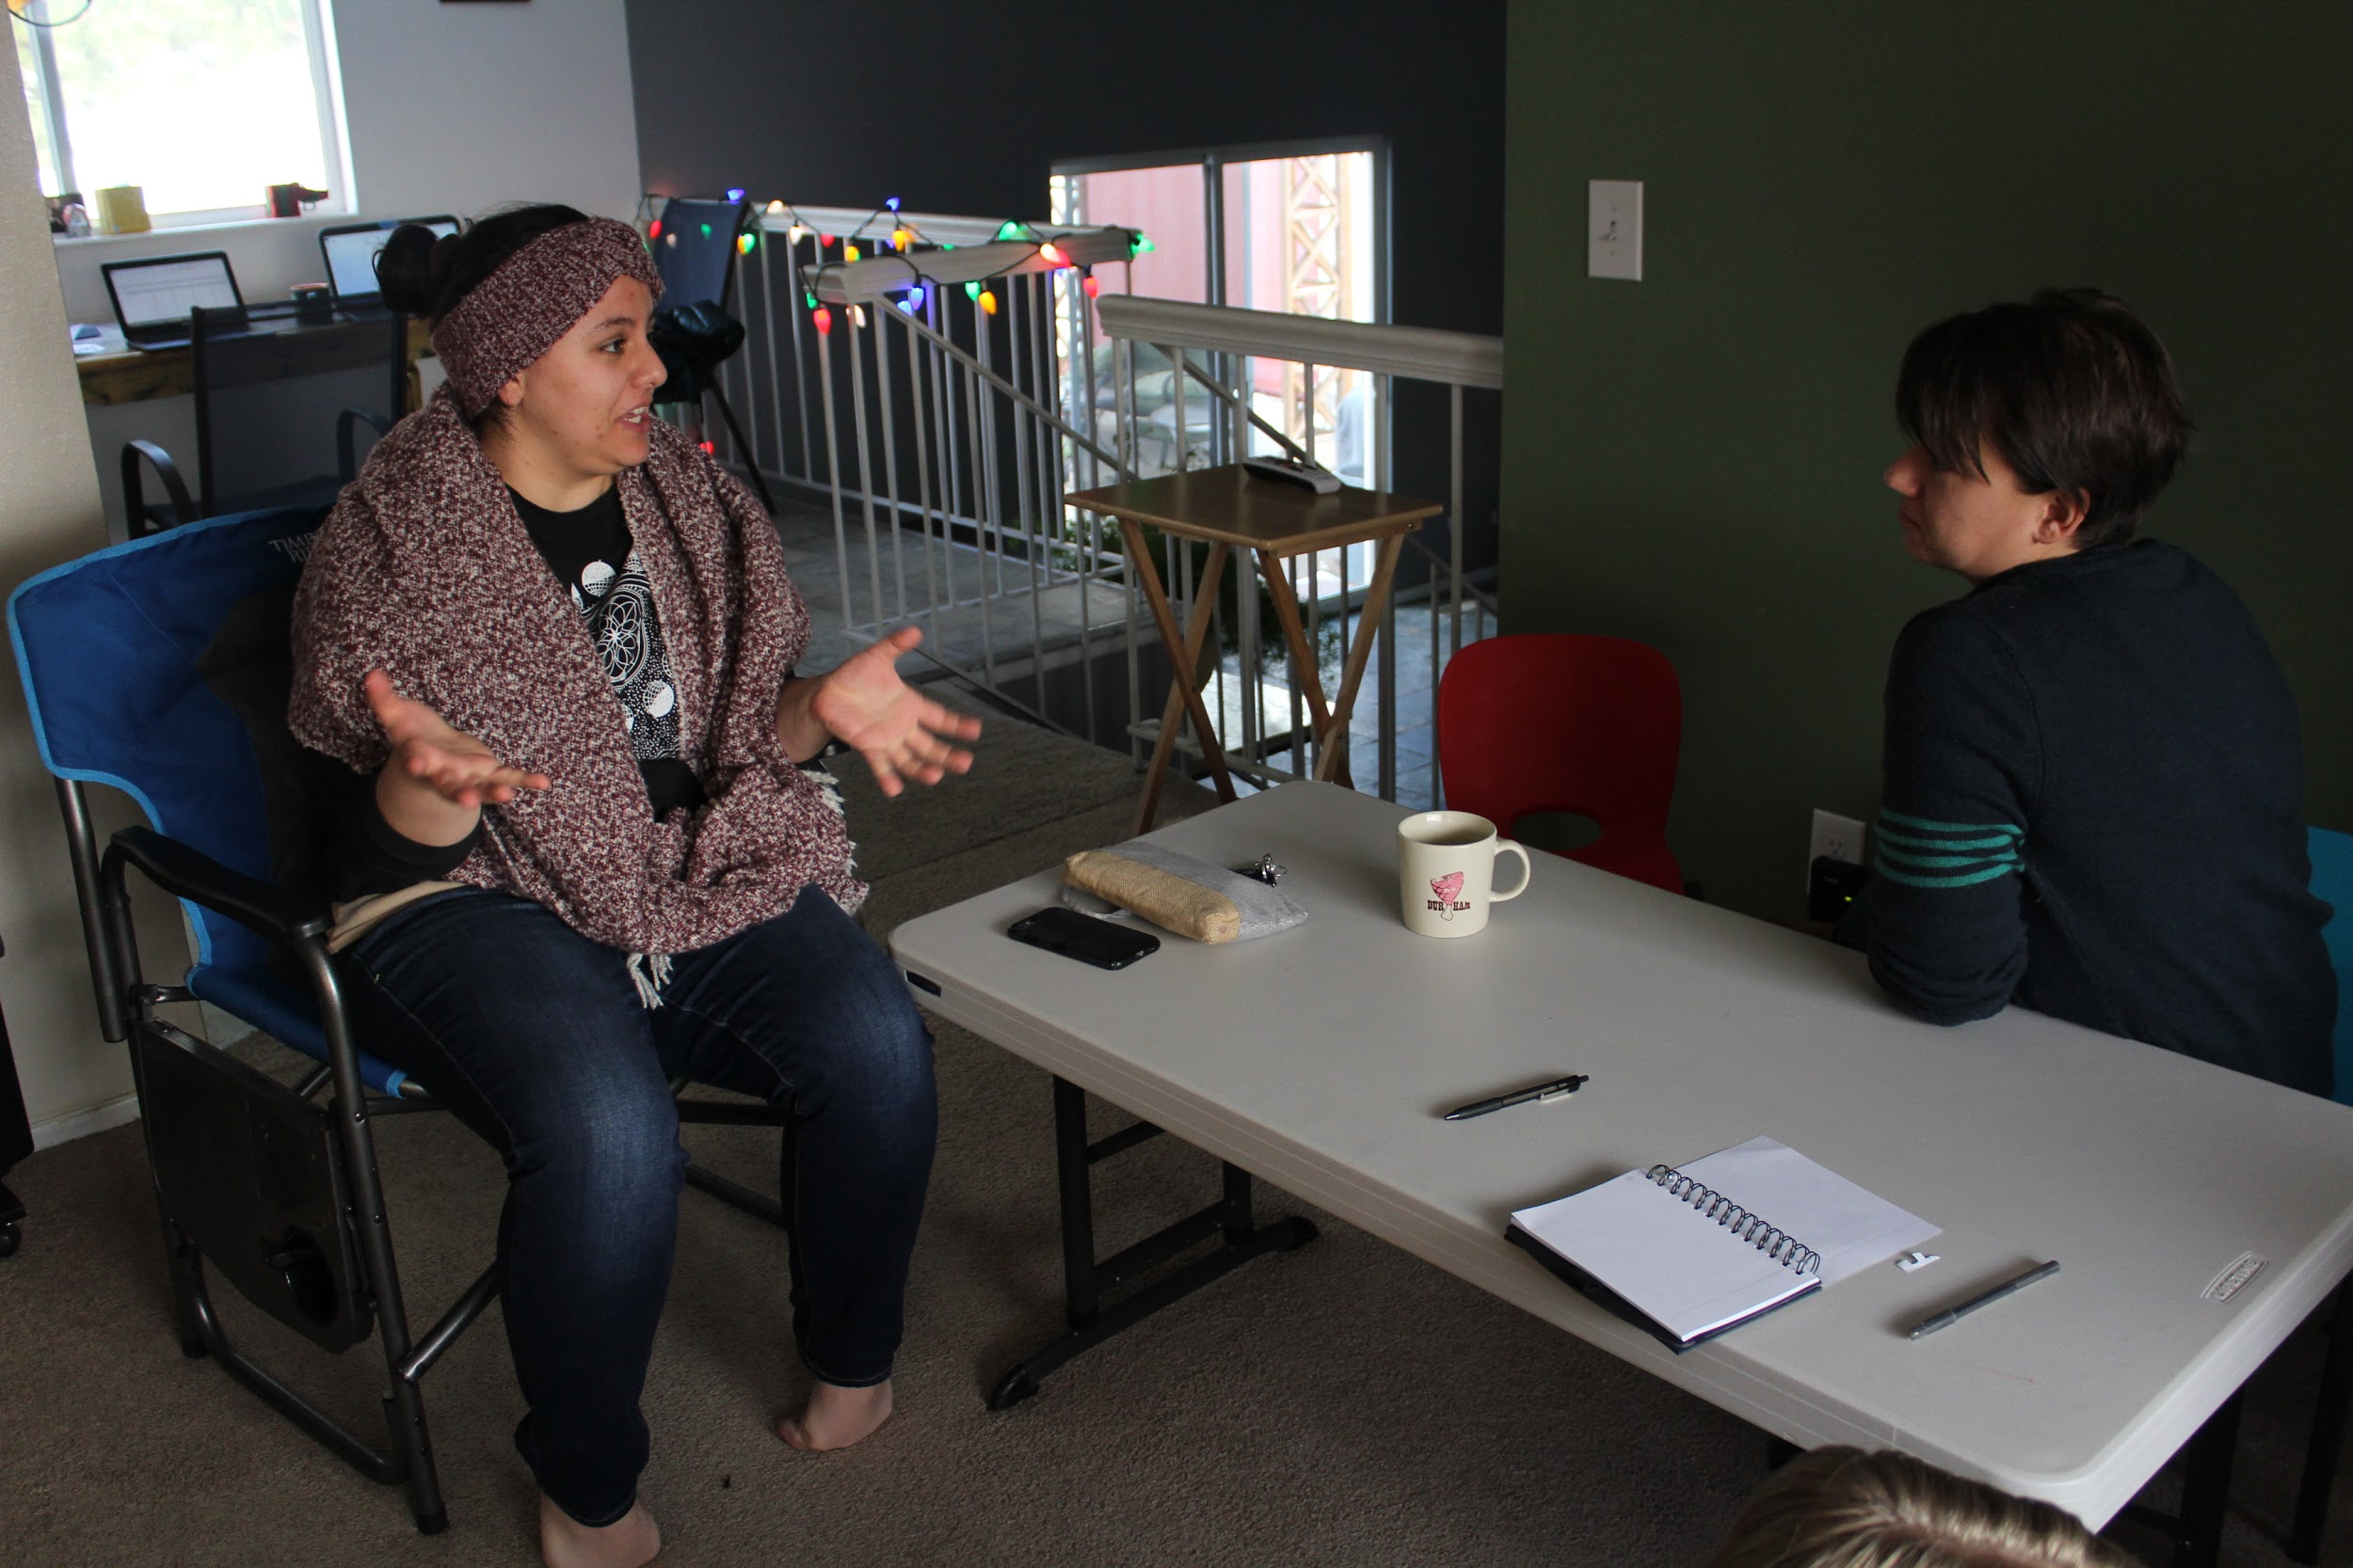The class reconvened and voted to work to increase campus counseling resources for sexual assault survivors’ recovery process and to build a comprehensive sexual assault-focused website. Students then had a group discussion to explicitly articulate the short and long-term goals of each project. For recovery resources, the class recognized the need for increased trauma-informed counseling. For the website, the class identified the goal of housing information regarding the university reporting process, available on and off campus resources, definitions surrounding the topic, and other crucial sexual assault information for students all in one place.

Once the projects and goals were finalized, each student created a rough timeline for the spring semester that included tasks that needed to be completed, allotted times for each tasks, and backup plans. When the spring semester began, the class met with various university staff, including Dean of Students Lori McDonald and the Women’s Resource Center Counseling Coordinator Kristy Bartley, in order to determine the feasibility of both projects. With help from the Dean of Students and the Women’s Resource Center, the class projects were finalized and work began.

**Pursuing Spring Project: Website**

Sexualassault.utah.edu is intended to be a comprehensive, accessible, and easily navigable website which provides information on sexual assault, available resources for survivors and secondary survivors, and the reporting process at the University of Utah. This website is meant to empower students and other University-affiliated individuals by offering support and connections to existing resources and to encourage such individuals to report incidences of sexual assault when possible. Ultimately, sexualassault.utah.edu hopes to support and educate the campus community and change the climate surrounding sexual assault.  
 In developing the website, desired features were identified and an extensive outline covering each tab and page was created. This outline was then presented to the University Marketing and Communications Department and approved by the Dean of Students Office. Each section was then populated with information gathered from existing University and community organizations and their websites. All content was reviewed by University partners to ensure accuracy and inclusivity. Final website content was then submitted to the Marketing and Communications Department and the Dean of Students for development and final approval, respectively.

**Pursuing Spring Project: Counseling**

The class’ second goal was to increase resources for survivors and secondary survivors of sexual assault on campus. We reached out to various counseling and sexual assault recovery resource centers and asked them to identify their largest, most pressing needs and how our group could help them out. This approach led to a collaboration with the Women’s Resource Center who identified their needs as: funding for increased staff hours, funding for a summer practicum student to provide counseling over the summer, and increased space. To address the Women’s Resource Center’s needs, the class used its course funds to sponsor a summer practicum student for the summer of 2017. The class also developed a proposal for the upcoming budget cycle about funding full-time hours for Counseling Coordinator, Kristy Bartley, and continued funding for future summer practicum students. This budget proposal was presented to the Presidential Safety Task Force co-chairs.

**Outcomes**

***Website*:** The content of the website was thoroughly researched in order to identify every available resource on campus for reporting, support for both survivors and secondary survivors, answers to the most commonly asked questions, and a comprehensive list of definitions that align with University and Office of Equal Opportunity policy. This information was then synthesized into a format that is easy to navigate, discrete, and comprehensive. The website was edited and approved by members of multiple departments across campus.

The content intended for the sexualassault.utah.edu website was submitted to the Dean of Students for final approval and was under development by the University Marketing and Communications Department at the time this report was written. Although the website is not yet available to the campus community, the Praxis Lab Summit helped make people aware of the new resource. When the website is published, members of the University and broader community will be able to easily identify the resources available to them. This will ideally improve the wellbeing of both primary and secondary survivors and contribute to an improved campus climate.

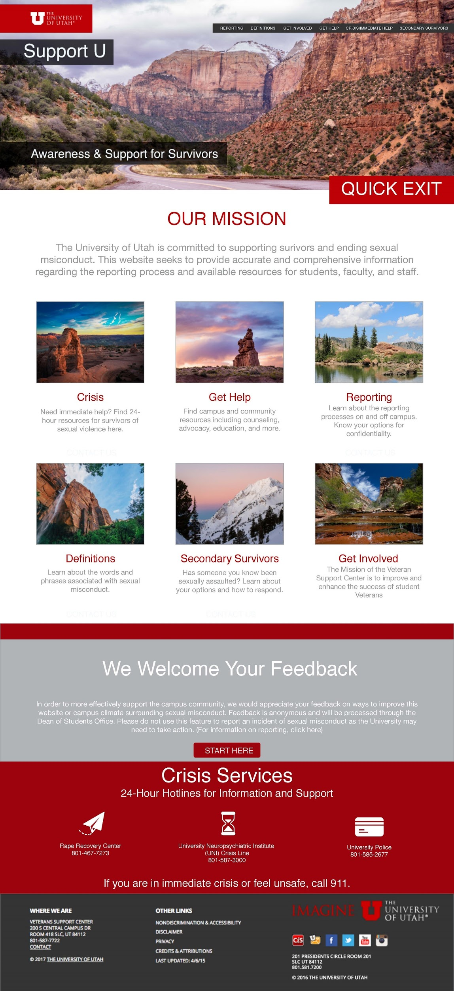

***Counseling*:** The first aspect of the counseling project was the use of course funds to sponsor a summer practicum student. In addition, a proposal was created that suggested the reallocation of budgetary funds. Once finalized, this proposal was presented to the Presidential Safety Task Force co-chairs.

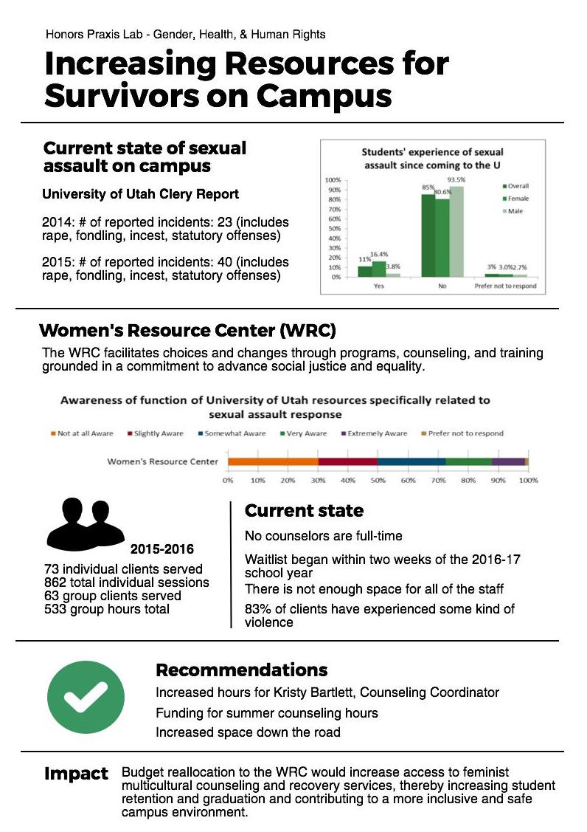

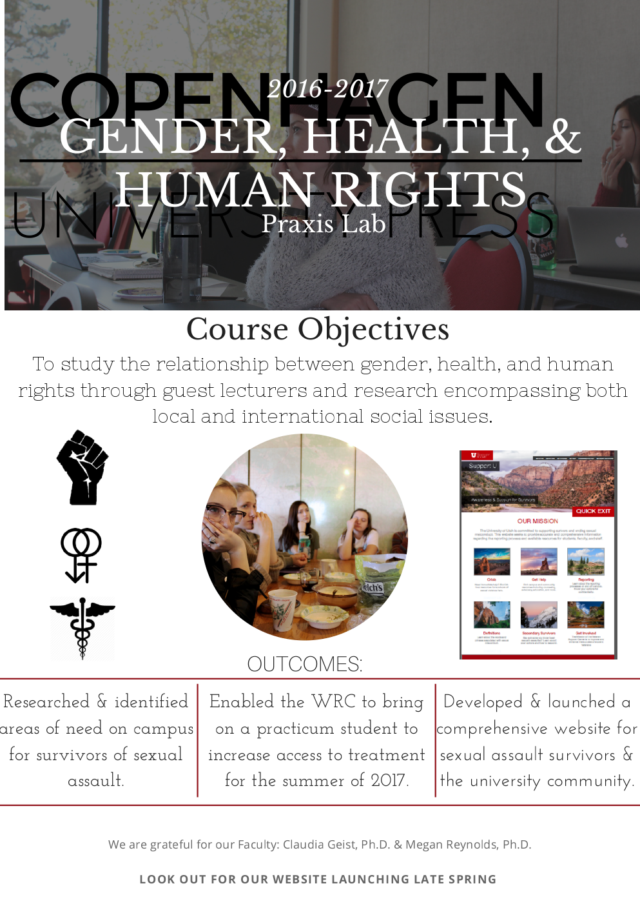**Impact**

***Students:*** The past nine months of our collective involvement in this Praxis Lab have been intensive, eye opening, and have positively impacted each of us as students. Each student has highlighted the specific impact this Praxis Lab has had on their experience, revealing many shared sentiments among students. Students described the experience as “eye-opening”, “shocking”, “engaging”, “inspiring” and “invaluable.” Ultimately, this Praxis Lab has allowed each of us to broaden our global perspectives and take on the task of understanding the disparities that exist in the three realms of gender, health, and human rights. We were intrigued by how interrelated these three fields are. There is a collective sense that this class approached certain important issues that we may not have encountered had we not taken this class.

One of the most significant impacts this Praxis Lab had on us was learning that even a small group of students at a large university can create a "powerful" and "lasting impact"through "hard work", communication, and collaboration with each other and the rest of the campus community. We have each developed the passions to educate those around us on the distressing issues we have discussed and to advocate for survivors of sexual assault.

The collective impact of this Praxis Lab extends beyond our spring project. Several of us feel that this experience has ignited a desire to conduct more research on the issue of sexual assault on our campus through UROP, other campus research endeavors, and even inspired career paths of advocacy and community health prevention work.

***Faculty Statements:***

This class has changed my perception of what can be achieved within the scope of a college course. Students performed at the level of graduate students in the seminar setting of the fall semester. In the hands-on spring semester, they were creative, independent, and persistent. I hope to be able to work with some of the students from our class in the future, be it for honors theses, doing independent research, or just to serve as mentor in the future. I feel fortunate to have met future leaders within their fields. I hope we will be able to meet as a group for many semesters to come. ~ Dr. Claudia Geist

Working with this group of students was by far the most enjoyable experience I have had as an instructor. Academically, they were prepared, engaged, responsive and proactive. Personally, they were conscientious, mature and funny. The only downside to spending a year with these remarkable young people is that it had to end, although I expect many ties to survive the exciting transitions in store for them. ~ Dr. Megan Reynolds

**Future**

***Website*:** Once the website is up and running, we want to make sure that the University of Utah community is fully aware of this resource and how to navigate it. We want to emphasize the many purposes it can serve: a tool for education, response, and support. Increasing awareness about our class’ website will help establish a supportive, healthy campus with members who are knowledgeable about sexual assault and about how to seek and provide help. In an effort to provide expansive awareness, we plan to engage with campus and community outreach opportunities.

**Salt Lake Tribune.** We have been corresponding with a Salt Lake Tribune journalist who is enthusiastic about writing a piece on our class’ efforts and website. We will work with this journalist to ensure that there is continued dialogue about sexual assault on campuses and to spread the word about our website.

**KRCL/ KUTE.** A few students from our Praxis Lab were welcomed onto KRCL, a listener-supported community radio station in Salt Lake City, to discuss our project and were invited back to talk more about the website. We plan to bring more students from our lab to talk about how our website can be a great resource for on and off campus community members. We also plan to work with the on campus radio station to talk directly to the campus community about our website and about on campus resources.

**University Marketing and Communications.** Our class plans to work with campus marketing to enhance the visibility of our website through posters and flyers that can be displayed throughout campus.

Mock up poster and/ or flyer designs:

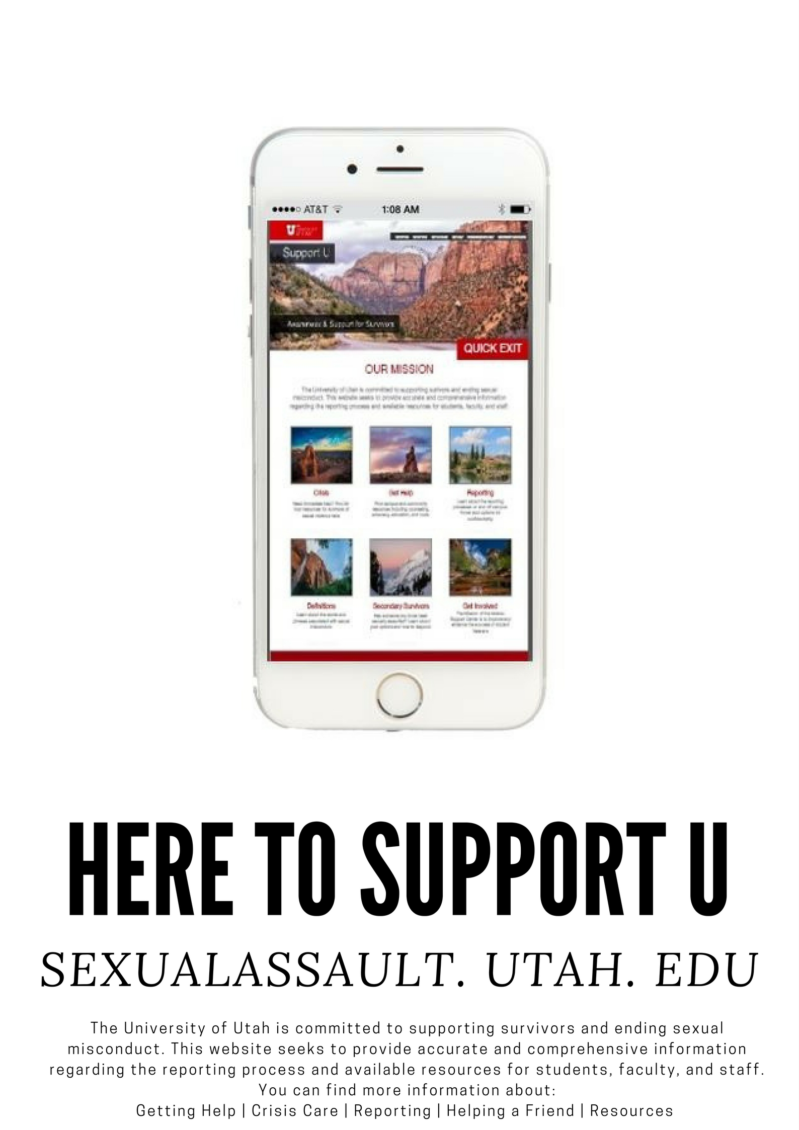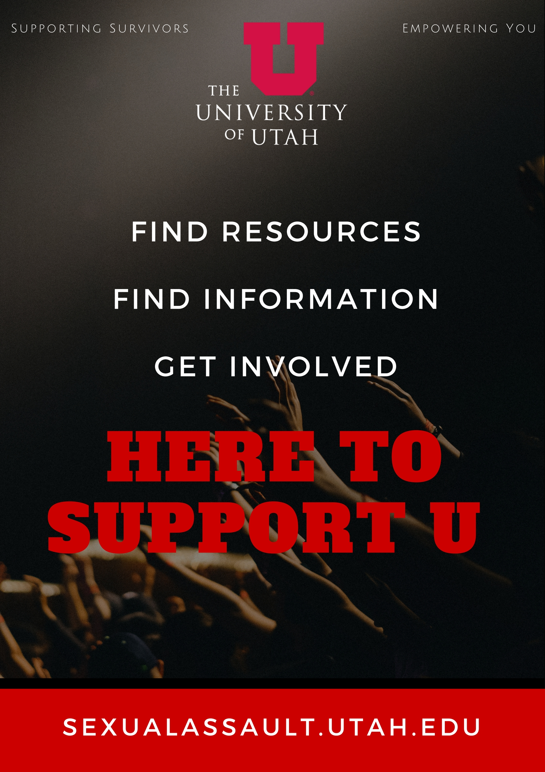

**Departmental listserves, courses, etc.** We hope to work with faculty and administration to make sure that knowledge on how to access information and recovery resources for sexual assault survivors is easy to find. We plan to create opportunities for our website to be included in every course syllabus. We want to work with faculty and staff to make sure that information about our website is disseminated in the most effective way, whether it be through class orientations, emails, or in class interactions.

**Campus events.** We plan to attend on campus events to interact face to face with our campus community and enhance awareness about our website. We hope to engage people in our efforts and promote involvement. We also plan to work with orientation leaders and student government to make sure that they are able to spread the word about our website. We want to make sure that new students are promptly introduced to the website at orientation and sustain ongoing awareness throughout the year.

We are fortunate to be supported and sustained through the Dean of Students office who will continue to manage the website long term. The Dean of Students will be updating campus and community resources as they evolve and will manage feedback given by website users. This will ensure content relevance and strengthen the ability to support and inform our growing community.

Our Praxis Lab wants to ensure the sustainability of our efforts by continuing to update our website and to push for more effectiveness evidence for the WRC through individual dedication of our classmates and through items such as UROP projects. A large part of our project was advocating for more resources for counseling on campus at the WRC. Since we could not directly ensure that resources for counseling at the Women’s Resource Center will be delivered within this next academic year and budget cycle, it is likely that this advocacy effort is one that will be valuable to continue. One way that this may be addressed is through a UROP project that follows up with this summer’s WRC practicum to collect data on client well-being between the spring and fall semesters. This data would be used as concrete evidence to show to the University administration the following year/budget cycle to advocate for permanent funding for a summer practicum position at the WRC. The data collection will hopefully be developed and ensured through two UROP projects that students Rene Gilfillan and Nour Jaatoul have been granted for the summer of 2017.

Other aspects of sustainability that will need to be looked into is student involvement in advocating and presenting to a potential administrative audience in the future. It is likely that students from this class will remain in touch during the next academic year to do this as well as to ensure the website’s upkeep is going well and that it is being advertised effectively on campus. Furthermore, the class hopes that student groups such as SLC Against Sexual Assault and Students for Choice will be inspired by our class’s efforts to continue the conversation and put pressure on the administration to increase safety task forces and resources for survivors on campus.

**Acknowledgements**

The class wishes to acknowledge and express deep appreciation for the contributions of several collaborators, without whom these projects would not have been possible:



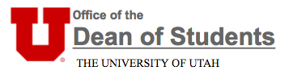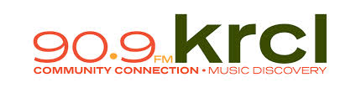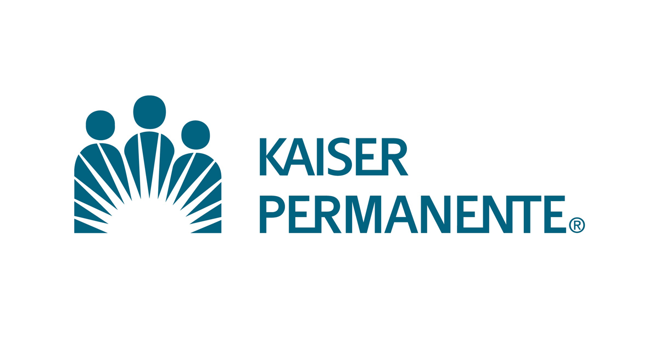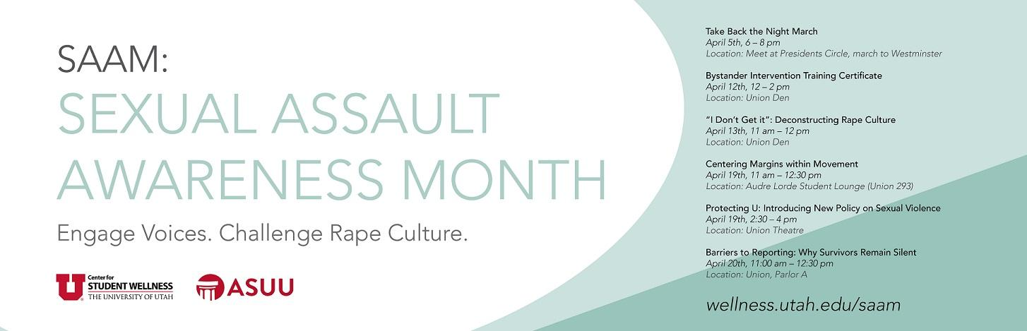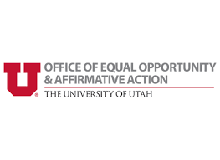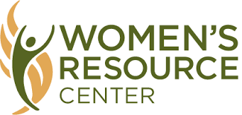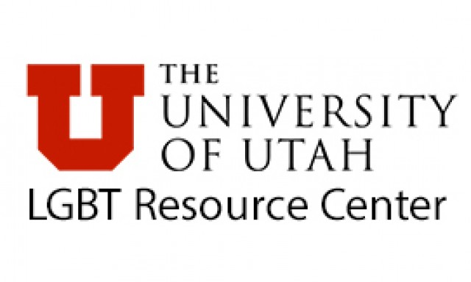

Special thanks to the Office of the Dean of Students and Lori McDonald for funding and overseeing the creation of sexualassault.utah.edu.

Thanks to University Marketing and Communications for facilitating the creation of the website.

Thanks to the Women’s Resource Center for encouraging our efforts to provide additional resources to survivors on campus, working closely with us to explore potential options and impact, and ultimately collaborating with us to fund an additional summer counselor.

Thanks to the Barbara and Norman Tanner Center for Nonviolent Human Rights for originating the idea for a Praxis lab surrounding the theme of human rights and for generously involving students in all of their programming throughout the year.

Thanks to the University of Utah Honors College and University of Utah Health Sciences for sponsoring the creation of this Praxis Lab and providing funding for our projects.

Thanks to the staff members from the Women’s Resource Center, the LGBT Resource Center, the Center for Student Wellness, and the Office for Equal Opportunity and Affirmative Action who contributed feedback in developing content for the website: Kristy Bartley, Max Wright, Maya Jolley, Kassy Keen, Jenna Templeton, Jodi Peterson, Darrah Jones, and Sherrie Hayashi.

Thanks to the many guest speakers from the university and the community who lent their expertise to help the class establish a context of issues in gender, health, and human rights: Dr. Wade Cole, Associate Professor at the University of Utah Department of Sociology; Dr. Thomas Maloney, Director of the University of Utah Barbara and Norman Tanner Center for Nonviolent Human Rights; Dr. Deen Chatterjee, Senior Advisor and Professorial Fellow at the University of Utah S.J. Quinney College of Law; Dr. Nicole Mihalopoulos, Adolescent Medicine Division Chief at the University of Utah Department of Pediatrics; Jessica Lynn, President of Your True Gender and transgender advocate; Dr. Sara Hart, Associate Professor (Clinical) at the U of U College of Nursing; Dr. Michael Varner, Vice-Chair of Research at the U of U Department of Obstetrics/Gynecology; Dr. Holly Bullock, Family Planning Fellow at the U of U Department of Obstetrics/Gynecology; and Dr. Sharon Talboys, Assistant Professor at the Westminster College Department of Public Health.

Thanks to KRCL Radio, the Salt Lake Tribune, and the Utah Chronicle for their media coverage of our efforts.